FORT BRAGG AREA RESOURCES
Agency | Address | Phone | Map Area
CRISIS/COUNSELING SERVICES
24/7 Crisis Line |  | 1-855-838-0404
AA Hotline |  | 1-877-546-9286
Access to Mental Health Services |  | 1-800-555-5906
Behavioral Resource Services |  | 707-472-2309
Manzanita Services | 410 Jones Street, Ukiah | 707-463-0405
Mendocino Coast Clinic | 205 South Street, Fort Bragg | 707-964-1251 | C7
Mendocino Coast Hospitality Center | 101 North Franklin Street, Fort Bragg | 707-961-0172 | B4
Mendocino County AIDS/Viral Hepatitis Network | 148 Clara Ave, Ukiah | 707-462-1932
Redwood Community Crisis Services | 544 S Main Street, Fort Bragg | 707-961-0308 | B6
Redwood Children’s Services | 32670 Highway 20, Fort Bragg | 707-964-4770
SUDT  (Substance Use Disorder Treatment) | 790 South Franklin Street, Fort Bragg | 707-961-2665 | B7
Suicide Hotline |  | 1-800-273-8255
Veterans Crisis Hotline |  | 1-800-273-8255
EMPLOYMENT SERVICES
Employment Development Department (EDD) | 631 South Orchard Ave, Ukiah | 707-463-5710
Mendocino Works | 1211 Del Mar Drive, Fort Bragg | 707-964-3218 | A9
Unemployment |  | 1-800-300-5616
FAMILY SERVICES
Mendocino County Youth Project  (Call for Services) |  | 707-489-8002
North Coast Opportunities (Child Care) | 111 A Boatyard Drive, Fort Bragg | 707-964-3080
Project Sanctuary (Domestic Violence) | 461 North Franklin Street, Fort Bragg | 707-961-1507 | C3
Safe Passage Family Resource Center | 325 East Redwood Ave, Fort Bragg | 707-961-1100 | D4
Tapestry Family Services | 290 East Gobbi Street, Ukiah | 707-463-3300
FOOD/CLOTHING SERVICES
Food Bank  M-F: 12-3pm/Seniors (60+) M-F: 10:00-11:30am  Wed: 4:30-5:30  Snack Bag Program Tuesday, Thursday 12-2 | 910 North Franklin Street, Fort Bragg | 707-964-9404 | C2
Hospitality House  Dinner: M-F 3:00-4:00 | 237 North McPherson Street, Fort Bragg | 707-961-1150 | C4
Our Lady of Good Counsel Church  Sunday 12:00pm (sack lunch) | 605 Maple Street, Fort Bragg | 707-964-0229 | D5
Trinity Lutheran Church  Monday 12:00pm (sack lunch) | 620 East Redwood Street, Fort Bragg | 707-964-5032 | D4
Mendocino Presbyterian Church  Tuesday 1:30(sack lunch)  Thursday 3:00-5:00 (pick up bag food) | 44831 Main Street, Mendocino | 707-937-5441
Evergreen Church-  Providing hot lunch (Across from Library) Every Saturday | East Laurel Street |  | C3
GOVERNMENT SERVICES
Fort Bragg City Hall | 416 North Franklin Street, Fort Bragg | 707-961-2823 | C4
Fort Bragg Police Department | 250 Cypress Street, Fort Bragg | 707-961-2800 | B7
Fort Bragg Unified School District | 312 South Lincoln Street, Fort Bragg | 707-961-2850 | E5
Mendocino County Public Library | 499 East Laurel Street, Fort Bragg | 707-964-2020 | C4
US Post Office | 203 North Franklin Street, Fort Bragg | 707964-2302 | B4
Department of Motor Vehicles | 410 South Franklin Street, Fort Bragg | 1-800-777-0133
Fort Bragg HHSA | 764 South Franklin Street, Fort Bragg | 707-962-1000
HEALTH
Mendocino Coast Clinic | 205 South Street, Fort Bragg | 707-964-1251 | C7
Mendocino Coast Adventist Hospital | 700 River Drive, Fort Bragg | 707-961-1234 | C7
Redwood Coast Regional Center | 270 Chestnut Street, Fort Bragg | 707-964-6387 | C6
WIC (Women, Infants & Children) | 120 Fir Street, Fort Bragg | 707-964-7106 | B3
Coastal Street Medicine  Wednesdays 9am-11:30am  Mendocino Presbyterian Church  2nd & 4th Tuesday 1pm-3pm | 101 North Franklin Street, Fort Bragg  44831 Main Street, Mendocino | 707-961-0172  707-937-5441 | B4
HOUSING
Mendocino Coast Hospitality Center  Referrals/Resources/Mail/Mental Health Services 8:30am-12 / 1pm-3pm | 101 North Franklin Street, Fort Bragg | 707-961-0172 | B4
Hospitality House Shelter  Clothing Closet/Laundry & Shower Services M-F 9:30-1:30 | 237 North McPherson Street, Fort Bragg | 707-961-1150 | C4
Community Development Commission | 1076 North State Street, Ukiah | 707-463-5462
LEGAL, FINANCIAL & ADVOCACY SERVICE
Child Support Benefits |  | 1-866-901-3212
Legal Services of Northern California | 421 North Oak Street, Ukiah | 707-462-1471
Ombudsman |  | 1-888-452-8609
Social Security | 521 South Orchard Ave, Ukiah | 1-888-590-2706
SENIOR & DISABLED SERVICES
Redwood Coast Senior Center | 490 North Harold Street, Fort Bragg | 707-964-0443 | D3
TRANSPORTATION
Dial-a-Ride | 190 East Spruce Street, Fort Bragg | 707-964-1800
MTA |  | 1-800-696-4682
UTILITIES
PG&E’s REACH Program |  | 707-459-3333
North Coast Energy Services (NCES) |  | 1-800-233-4480
VETERANS
Mendocino County Veterans Services | 360 North Harrison Street, Fort Bragg | 707-964-5823 | C4

Updated 04 /2021

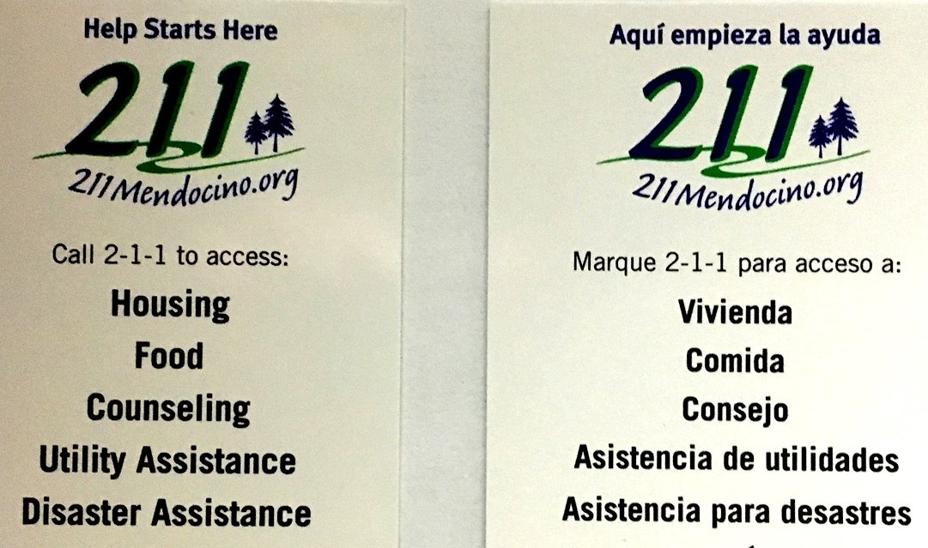
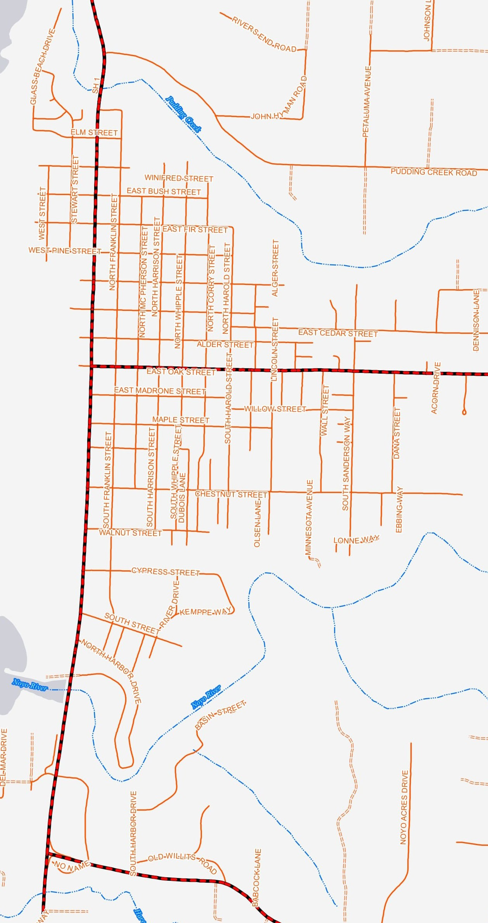

Fort Bragg Community Resources

A B C D E F G H

1

2
Spruce St

3

Laurel St

Redwood Ave

4

5

Hazel St

6

7

